Question 35. 35. (TCO 4) Which of the following statements is true? (Points : 4)
A timer or counter instruction must always be at the end of the rung.
A timer or counter instruction must always be at the beginning of the rung.
Two or more timer or counter instructions can be cascaded in series on the same rung.
All of the above
Question 36. 36. (TCO 4) Which of the following statements are true? Check all that apply.
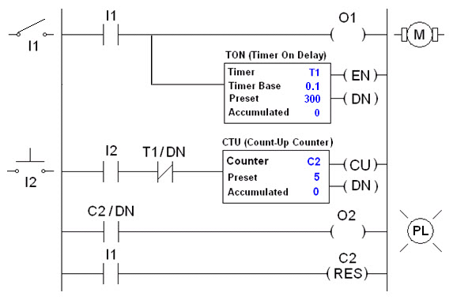(Points : 4)
Forty-five seconds after the toggle switch I1 is closed, push button I2 is pressed three times. The accumulated value in the counter instruction will show 3.
Twenty seconds after the toggle switch I1 is closed, the motor is still running.
The pilot light PL will turn on if the accumulated value in the counter instruction is 5 or higher.
Within 15 seconds after toggle switch I1 is closed, push button I2 is pressed 3 times. The accumulated value in the counter instruction will show 3.
Question 37. 37. (TCO 4) The toggle switch has been closed for two minutes. During the first 15 seconds after the closing of the toggle switch, push button I2 was pressed four times. Describe what the status of the motor and the pilot light (PL) will be at the two-minute mark.
(Points : 4)
Question 38. 38. (TCO 4) Write a ladder logic program that will turn a pilot light on one minute after a toggle switch I1 is closed (Use only PLC instructions.). You may either draw the diagram and submit to your instructor separately, or describe in words how to program for this process. (Points : 4)
Question 39. 39. (TCO 5) The content of register R0 is shown below. What are the least significant 4-bits of register R7?
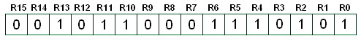(Points : 4)
0101
1000
0010
0111
Question 40. 40. (TCO 5) What is the decimal value stored in the 16-bit register R0?
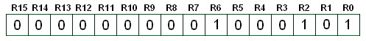(Points : 4)
5
1
64
69
Question 41. 41. (TCO 5) The content of register R0 and a ladder logic program are given below. Determine which statements are true. Check all that apply.
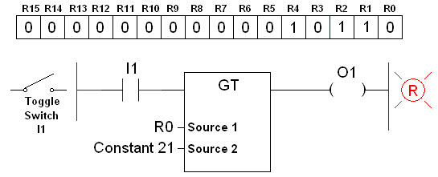(Points : 4)
The decimal value stored in the 16-bit register R0 is 18.
If the toggle switch I1 is closed, then the red light turns on.
If the content of register R0 changes to 25 and the toggle switch is closed, then the red light turns on.
The instruction in the middle is a compare instruction.
Question 42. 42. (TCO 5) The content of register R0 and a ladder logic program are given below. Determine which statements are true. Check all that apply.
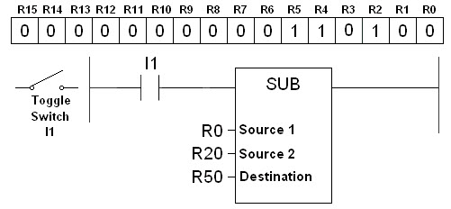(Points : 4)
If the decimal number stored in register R20 is 27, then the decimal number 25 will be stored in register R50 after the toggle switch I1 is closed.
The instruction on the right is a math instruction.
Toggle switch I1 must be closed for SUB operation to take place.
The decimal number in register R0 is 26.
Question 43. 43. (TCO 5) What decimal number will be stored in register R50 after the toggle switch I1 is closed?
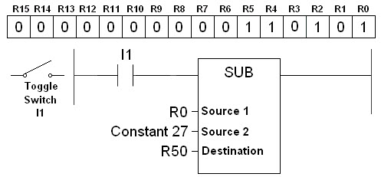(Points : 4)
26
53
27
80
Question 44. 44. (TCO 5) Describe how the MUL (multiplication) instruction operates. (Points : 5)
Question 45. 45. (TCO 5) Describe how the GE (greater than or equal) instruction operates. (Points : 5)
Question 46. 46. (TCO 5) Describe the purpose of compare instructions as applied to the PLC. (Points : 5)
Question 47. 47. (TCO 5) The content of register R0 and a ladder logic program are given below. Which of the following statements is true?
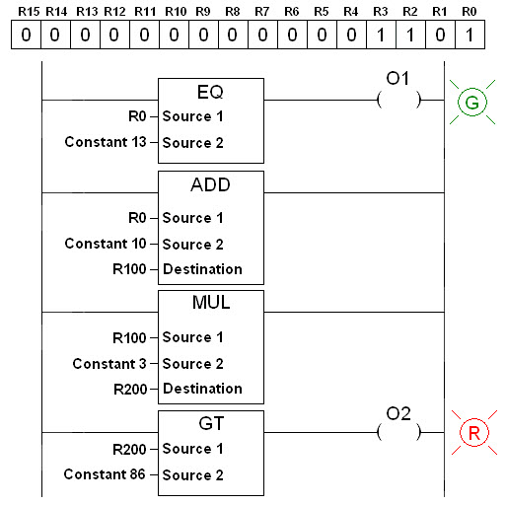(Points : 4)
Both the green light and the red light are on.
The green light is on, and the red light is off.
The green light is off, and the red light is on.
Both the green light and the red light are off.
Question 48. 48. (TCO 5) In the ladder logic program given below, what number will be stored in register R300 when all operations are performed?
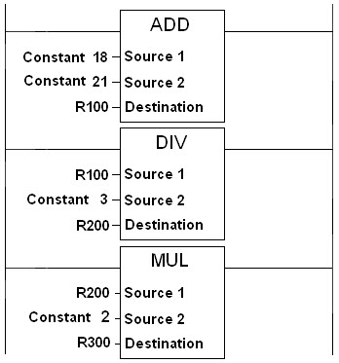(Points : 4)
13
39
26
52
Question 49. 49. (TCO 6) Describe a closed-loop control system. (Points : 5)
Question 50. 50. (TCO 6) Which of the following are examples of closed-loop control systems? Check all that apply. (Points : 4)
The radiator fan in a car that turns on any time the engine is running
The radiator fan in a car that turns on whenever the engine temperature is high
The street lights that turn on whenever it gets dark
The street lights that turn on everyday at 6:00 p.m.
The water level in a tank that is controlled by a human being
The water level in a tank that is controlled by a float sensor
Question 51. 51. (TCO 6) Define what is meant by the term process control system. (Points : 5)
Question 52. 52. (TCO 6) Which of the statements is true for the control system block diagram shown below?
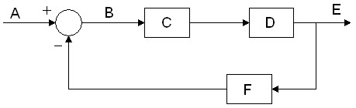(Points : 4)
C is the process, and F is the output.
B is the error signal, and F is the feedback sensory device.
C is the controller, and B is the input.
E is the output, and F is the input.
Question 53. 53. (TCO 6) Which of the following is the response of a stable system?
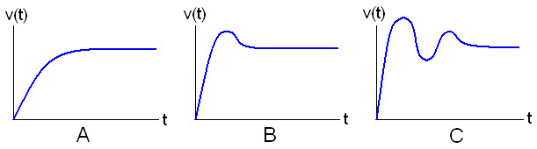(Points : 4)
A
B
C
All of the above
Question 54. 54. (TCO 6) Define data acquisition. (Points : 5)
Question 55. 55. (TCO 6) Which of the following is a type of signal conditioning? (Points : 4)
Amplification
Linearization
Filtering
All of the above
Question 56. 56. (TCO 6) Briefly describe the concept of PID controllers. (Points : 5)
Question 57. 57. (TCO 6) An optical wheel with 8 holes, as shown below, is connected to the shaft of a motor. The wheel turns between the transmitter and receiver of a photo sensor that generates a series of 0-10 V pulses as the wheel interrupts the transmitted infrared signal. The sensor is connected to the input module of a PLC. An up-counter instruction has counted 560 pulses in 10 seconds. What is the speed of the motor in rpm (revolution per minute)?
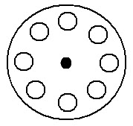(Points : 4)
560 rpm
700 rpm
420 rpm
600 rpm
Question 58. 58. (TCO 7) A single output device has failed while the remainder of the PLC system is functioning normally. The indicator light on the output module indicates that a signal is being sent to the output point where the device is connected. Technician A says you would next trace the circuit back through the logic to locate the input(s). Technician B says you would next check the point where the output device's field wiring is connected to the output rack. Who is correct? (Points : 4)
Only Technician A
Only Technician B
Both Technician A and Technician B
Neither Technician A nor Technician B
Question 59. 59. (TCO 7) Which of the following statements is true for PLC analog input modules? (Points : 4)
Input modules can accept variable voltage levels.
Input modules can only accept AC signals.
Input modules can only accept DC signals.
All of the above
Question 60. 60. (TCO 7) What are some of the applications of HMI devices? Check all that apply. (Points : 4)
To replace the CPU in a PLC
To monitor the status of equipment
To quickly identify equipment breakdown
To create a ladder logic program

